**Q1** **Import the dataset and do usual exploratory analysis steps like checking the structure & characteristics of the dataset:**

**Part (1):Data type of columns in a table:**

**Ans:** For example, data type from orders table:

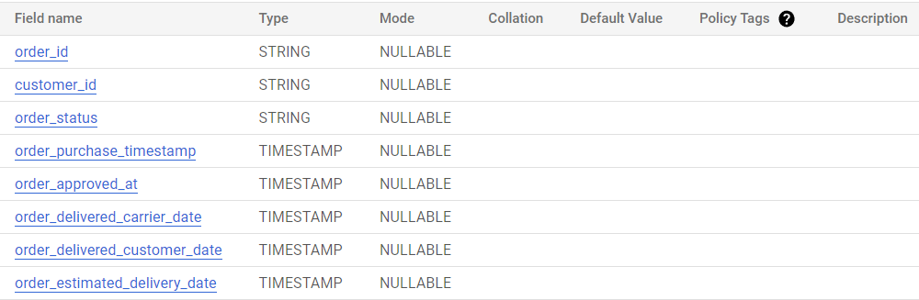

**Part (2):Time period for which the data is given:**

**Query Code:**

select

min(order_purchase_timestamp) as min_time_stamp,

max(order_purchase_timestamp) as max_time_stamp

from `scaler-dsml-sql-373605.target_sql.orders`

**Query Result:**



**Part (3): Cities and States of customers ordered during the given period:**

**Query Code:**

select

distinct

customer_state,

customer_city

from `scaler-dsml-sql-373605.target_sql.customers`

order by customer_state,customer_city

**Query Result:**

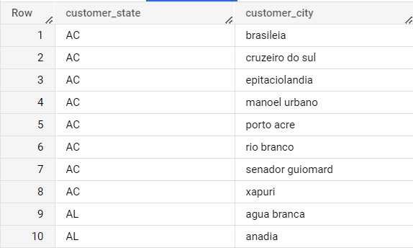

**Q:2** **In-depth Exploration:**

**Part (1) (i) : Is there a growing trend on e-commerce in Brazil?**

**Query Code:**

select

extract (year from timestamp (o.order_purchase_timestamp )) as year,

extract (month from timestamp (o.order_purchase_timestamp )) as month,

count(o.order_id) as cnt_ord

from `scaler-dsml-sql-373605.target_sql.orders` as o

inner join `scaler-dsml-sql-373605.target_sql.customers`as c

on o.customer_id=c.customer_id

group by year,month

order by year,month

**Query Result:**

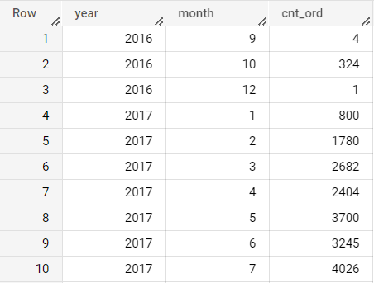

**Part(1) (ii) How can we describe a complete scenario? Can we see some seasonality with peaks at specific months?**

**Query Code:**

with cte_1 as(

select

extract (year from timestamp (o.order_purchase_timestamp )) as year,

extract (month from timestamp (o.order_purchase_timestamp )) as month,

count(o.order_id) as cnt_ord

from `scaler-dsml-sql-373605.target_sql.orders` as o

inner join `scaler-dsml-sql-373605.target_sql.customers`as c

on o.customer_id=c.customer_id

group by year,month

order by year,month

),

cte_2 as (

select

year,

month,

cnt_ord

from cte_1

where year=2016

),

cte_3 as(

select

year,

month,

cnt_ord

from cte_1

where year=2017

),

cte_4 as (

select

year,

month,

cnt_ord

from cte_1

where year=2018

)

select

ct3.month,

ifnull(ct2.cnt_ord,0) as cnt_ord_2016,

ifnull(ct3.cnt_ord,0) as cnt_ord_2017,

ifnull(ct4.cnt_ord,0) as cnt_ord_2018,

(ifnull(ct2.cnt_ord,0)+ifnull(ct3.cnt_ord,0)+ifnull(ct4.cnt_ord,0)) as total_cnt_ord

from cte_3 as ct3

left join cte_2 as ct2

on ct3.month=ct2.month

left join cte_4 as ct4

on ct3.month=ct4.month

order by ct3.month

**Query Result:**

**Part (2): What time do Brazilian customers tend to buy (Dawn, Morning, Afternoon or Night)?**

Here, I took assumptions like

* Dawn period is 00:00:00 to 05:59:59
* Morning period is 06:00:00 to 11:59:59
* Afternoon period is 12:00:00 to 17:59:59
* Night period is 18:00:00 to 23:59:59

**Query Code:**

select distinct

Hour_stamp,

count(order_id) over(partition by hour_stamp) as cnt_ord

from (select

customer_id,

order_id,

case

when extract (hour from timestamp (order_purchase_timestamp) )>=1 and extract (hour from timestamp (order_purchase_timestamp) )<6 then "dawn"

when extract (hour from timestamp (order_purchase_timestamp) )>=6 and extract (hour from timestamp (order_purchase_timestamp) )<12 then "Morning"

when extract (hour from timestamp (order_purchase_timestamp) )>=12 and extract (hour from timestamp (order_purchase_timestamp) )<18 then "Afternoon"

else "Night"

End as Hour_stamp from `scaler-dsml-sql-373605.target_sql.orders`) t

inner join `scaler-dsml-sql-373605.target_sql.customers` c

on t.customer_id=c.customer_id

order by cnt_ord

**Query Result:**

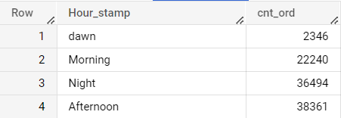

**Q:3 Evolution of E-commerce orders in the Brazil region:**

**Part (1): Get month on month orders by states**

**Query Code:**

select

c.customer_state,

extract (year from timestamp (o.order_purchase_timestamp)) as year,

extract (month from timestamp (o.order_purchase_timestamp)) as month,

count(o.order_id) as ord_cnt,

from `scaler-dsml-sql-373605.target_sql.orders` o

inner join `scaler-dsml-sql-373605.target_sql.customers` c

on o.customer_id=c.customer_id

group by c.customer_state,year,month

order by year,month,ord_cnt desc

**Query Result:**

**Part (2): Distribution of customers across the states in Brazil**

**Query Code:**

select

customer_state,

count(customer_id) as cnt_cid

from `scaler-dsml-sql-373605.target_sql.customers`

group by customer_state

order by cnt_cid desc

**Query Result:**

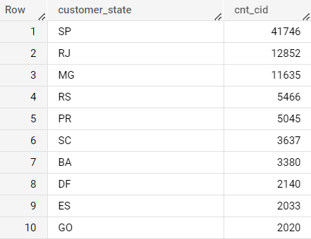

**Q:4 Impact on Economy: Analyze the money movement by e-commerce by looking at order prices, freight, and others.**

**Part (1): Get % increase in cost of orders from 2017 to 2018 (include months between Jan to Aug only) - You can use “payment value” column in payments table**

**Query Code:**

with cte_1 as (

select

extract (year from timestamp(order_purchase_timestamp)) as year,

order_id,

order_purchase_timestamp

from `scaler-dsml-sql-373605.target_sql.orders`

),

cte_2 as (

select

order_id,

order_purchase_timestamp,

extract (month from timestamp(order_purchase_timestamp)) as month

from cte_1

where extract (month from timestamp(order_purchase_timestamp)) between 1 and 8

),

cte_3 as (

select distinct

ct1.year,

ct2.month,

count(distinct py.order_id) over(partition by ct2.month) as cnt_ord,

round(sum(py.payment_value) over(partition by ct2.month),2) as sum_month_payment_value,

round(avg(py.payment_value) over(partition by ct2.month),2) as avg_month_payment_value

from cte_2 as ct2

inner join `scaler-dsml-sql-373605.target_sql.payments` as py

on ct2.order_id=py.order_id

inner join cte_1 as ct1

on ct1.order_id=py.order_id

where ct1.year=2017

order by ct2.month

),

cte_4 as (

select distinct

ct1.year,

ct2.month,

count(distinct py.order_id) over(partition by ct2.month) as cnt_ord,

round(sum(py.payment_value) over(partition by ct2.month),2) as sum_month_payment_value,

round(avg(py.payment_value) over(partition by ct2.month),2) as avg_month_payment_value

from cte_2 as ct2

inner join `scaler-dsml-sql-373605.target_sql.payments` as py

on ct2.order_id=py.order_id

inner join cte_1 as ct1

on ct1.order_id=py.order_id

where ct1.year=2018

order by ct2.month

)

select

concat(ct3.year,"-",ct4.year) as years,

ct3.month,

ct4.cnt_ord as cnt_ord_2018,

ct3.cnt_ord as cnt_ord_2017,

round(((ct4.cnt_ord-ct3.cnt_ord)/ct3.cnt_ord)*100,2) as percent_ord_change,

ct4.sum_month_payment_value as sum_month_payment_value_2018,

ct3.sum_month_payment_value as sum_month_payment_value_2017,

round(((ct4.sum_month_payment_value-ct3.sum_month_payment_value)/ct3.sum_month_payment_value)*100,2) as percent_sum_PV_change,

ct4.avg_month_payment_value as avg_month_payment_value_2018,

ct3.avg_month_payment_value as avg_month_payment_value_2017,

round(((ct4.avg_month_payment_value-ct3.avg_month_payment_value)/ct3.avg_month_payment_value)*100,2) as percent_avg_PV_change

from cte_3 as ct3

inner join cte_4 as ct4

on ct3.month=ct4.month

order by ct3.month

**Query Result:**

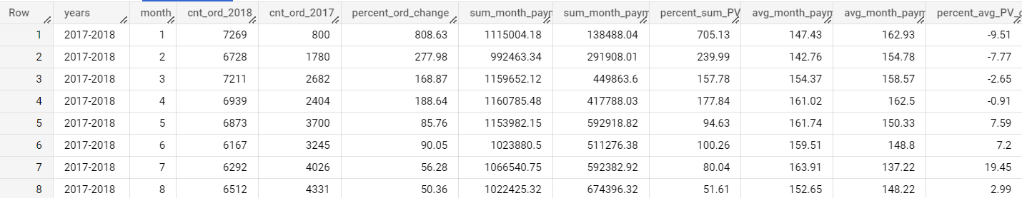

**Part (2): Mean & Sum of price and freight value by customer state**

**Query Code:**

with cte_1 as (

select

order_id,

customer_id

from `scaler-dsml-sql-373605.target_sql.orders`

),

cte_2 as (

select

c.customer_state,

c.customer_id

from `scaler-dsml-sql-373605.target_sql.customers` c

inner join `scaler-dsml-sql-373605.target_sql.orders` o

on c.customer_id= o.customer_id

),

cte_3 as (

select

o.order_id,

o.customer_id,

oe.price,

oe.freight_value,

from `scaler-dsml-sql-373605.target_sql.orders`o

inner join `scaler-dsml-sql-373605.target_sql.order_items` oe

on oe.order_id=o.order_id

)

select

distinct

ct2.customer_state,

round(avg(ct3.price) over(partition by ct2.customer_state ),2) as avg_price,

round(sum(ct3.price) over(partition by ct2.customer_state ),2) as sum_price,

round(avg(ct3.freight_value) over(partition by ct2.customer_state ),2) as avg_freight,

round(sum(ct3.freight_value) over(partition by ct2.customer_state ),2) as sum_freight,

from cte_2 as ct2

left join cte_3 as ct3

on ct2.customer_id=ct3.customer_id

order by avg_price,avg_freight,sum_price,sum_freight

**Query Result:**

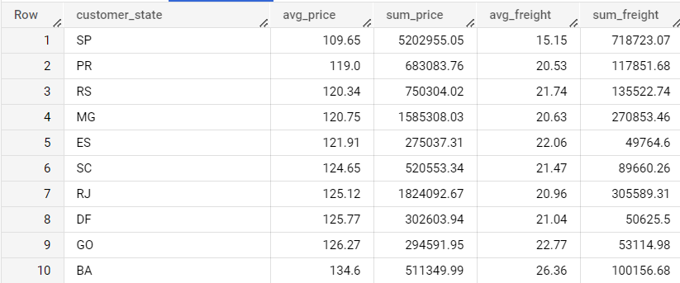

**Q:5 Analysis on sales, freight, and delivery time**

**Part (1): Calculate days between purchasing, delivering and estimated delivery**

**Query Code:**

select

order_id,

DATE_DIFF(DATE_4,DATE_1,day) as expected_days,

DATE_DIFF(DATE_3,DATE_1,day) as actual_days,

DATE_DIFF(DATE_2,DATE_1,day) as dispatch_days

from (select

order_id,

extract(date from timestamp(order_purchase_timestamp)) as DATE_1,

extract(date from timestamp(order_delivered_carrier_date)) as DATE_2,

extract(date from timestamp(order_delivered_customer_date)) as DATE_3,

extract(date from timestamp(order_estimated_delivery_date)) as DATE_4,

from `scaler-dsml-sql-373605.target_sql.orders`

) as t

where DATE_1 is not null and DATE_2 is not null and DATE_3 is not null and DATE_4 is not null

**Query Result:**

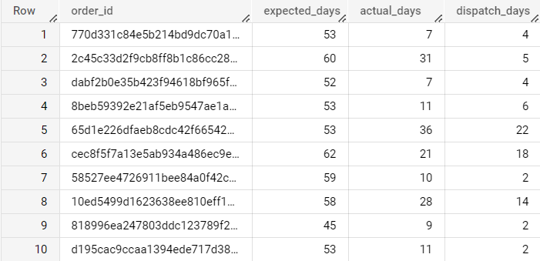

**Part (2): Find time_to_delivery & diff_estimated_delivery. Formula for the same given below:**

* + **time_to_delivery = order_purchase_timestamp-order_delivered_customer_date**
  + **diff_estimated_delivery = order_estimated_delivery_date-order_delivered_customer_date**

**Query code:**

select

order_id,

DATETIME_DIFF(DATETIME_2,DATETIME_1,day) as time_to_delivery,

DATETIME_DIFF(DATETIME_3,DATETIME_2,day) as diff_estimated_delivery

from

(select

order_id,

extract(DATETIME  from timestamp(order_purchase_timestamp)) as DATETIME_1,

extract(DATETIME  from timestamp(order_delivered_customer_date)) as DATETIME_2,

extract(DATETIME  from timestamp(order_estimated_delivery_date)) as DATETIME_3,

from `scaler-dsml-sql-373605.target_sql.orders`

) as t

where DATETIME_1 is not null and DATETIME_2 is not null and DATETIME_3 is not null

**Query Result:**

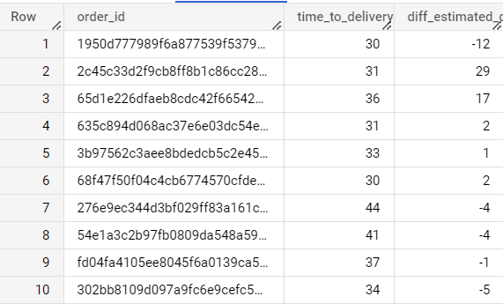

**Part (3) Group data by state, take mean of freight_value, time_to_delivery, diff_estimated_delivery**

**Query code:**

with cte_1 as (

select

order_id,

customer_id,

DATETIME_DIFF(DATETIME_2,DATETIME_1,day) as time_to_delivery,

DATETIME_DIFF(DATETIME_3,DATETIME_2,day) as diff_estimated_delivery

from (select

order_id,

customer_id,

extract(DATETIME  from timestamp(order_purchase_timestamp)) as DATETIME_1,

extract(DATETIME  from timestamp(order_delivered_customer_date)) as DATETIME_2,

extract(DATETIME  from timestamp(order_estimated_delivery_date)) as DATETIME_3,

from `scaler-dsml-sql-373605.target_sql.orders`

) as t

where DATETIME_1 is not null and DATETIME_2 is not null and DATETIME_3 is not null

)

select

distinct

c.customer_state,

round(avg(oe.freight_value) over(partition by c.customer_state),2) as avg_freight,

round(avg(ct1.time_to_delivery) over(partition by c.customer_state),2) as avg_time_to_delivery,

round(avg(ct1.diff_estimated_delivery) over(partition by c.customer_state),2) as avg_diff_estimated_delivery

from `scaler-dsml-sql-373605.target_sql.customers` as c

inner join cte_1 as ct1

on ct1.customer_id=c.customer_id

inner join `scaler-dsml-sql-373605.target_sql.order_items` as oe

on oe.order_id=ct1.order_id

order by c.customer_state,avg_freight,avg_time_to_delivery,avg_diff_estimated_delivery desc

**Query Result:**

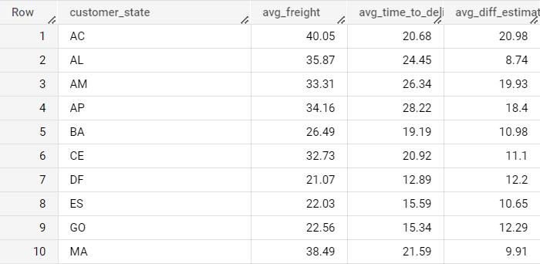

**Part(4) Sort the data to get the following:**

**Part (5) Top 5 states with highest/lowest average freight value - sort in desc/asc limit 5**

**Query Code:**

select

distinct

c.customer_state,

round(avg(oe.freight_value) over(partition by c.customer_state),2) as avg_freight,

from `scaler-dsml-sql-373605.target_sql.orders` as o

inner join `scaler-dsml-sql-373605.target_sql.customers` as c

on c.customer_id=o.customer_id

inner join `scaler-dsml-sql-373605.target_sql.order_items` as oe

on oe.order_id=o.order_id

order by avg_freight desc

limit 5

**Query Result:**

**Part (6) Top 5 states with highest/lowest average time to delivery**

**Query Code:**

with cte_1 as (

select

order_id,

customer_id,

DATETIME_DIFF(DATETIME_2,DATETIME_1,day) as time_to_delivery,

from (select

order_id,

customer_id,

extract(DATETIME  from timestamp(order_purchase_timestamp)) as DATETIME_1,

extract(DATETIME  from timestamp(order_delivered_customer_date)) as DATETIME_2

from `scaler-dsml-sql-373605.target_sql.orders`

) as t

where DATETIME_1 is not null and DATETIME_2 is not null

)

select

distinct

c.customer_state,

round(avg(ct1.time_to_delivery) over(partition by c.customer_state),2) as avg_time_to_delivery

from `scaler-dsml-sql-373605.target_sql.customers` as c

inner join cte_1 as ct1

on ct1.customer_id=c.customer_id

inner join `scaler-dsml-sql-373605.target_sql.order_items` as oe

on oe.order_id=ct1.order_id

order by avg_time_to_delivery desc

limit 5

**Query Result:**

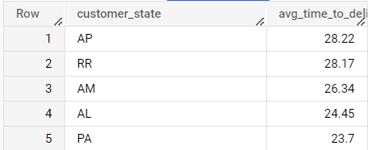

**Part (7) Top 5 states where delivery is really fast/ not so fast compared to estimated date**

**Query Code:**

with cte_1 as (

select

order_id,

customer_id,

DATETIME_DIFF(DATETIME_2,DATETIME_1,day) as time_to_delivery,

DATETIME_DIFF(DATETIME_3,DATETIME_2,day) as diff_estimated_delivery

from (select

order_id,

customer_id,

extract(DATETIME  from timestamp(order_purchase_timestamp)) as DATETIME_1,

extract(DATETIME  from timestamp(order_delivered_customer_date)) as DATETIME_2,

extract(DATETIME  from timestamp(order_estimated_delivery_date)) as DATETIME_3,

from `scaler-dsml-sql-373605.target_sql.orders`

) as t

where DATETIME_1 is not null and DATETIME_2 is not null and DATETIME_3 is not null

)

select*,

from (

select

distinct

c.customer_state,

round(avg(ct1.time_to_delivery) over(partition by c.customer_state),2) as avg_time_to_delivery,

round(avg(ct1.diff_estimated_delivery) over(partition by c.customer_state),2) as avg_diff_estimated_delivery

from `scaler-dsml-sql-373605.target_sql.customers` as c

inner join cte_1 as ct1

on ct1.customer_id=c.customer_id

inner join `scaler-dsml-sql-373605.target_sql.order_items` as oe

on oe.order_id=ct1.order_id ) as t

order by avg_diff_estimated_delivery desc

limit 5

**Query Result:**

**Q:6 Payment type analysis:**

**Part (1) Month over Month count of orders for different payment types**

**Query Code:**

select

extract (year from timestamp (o.order_purchase_timestamp )) as year,

extract (month from timestamp (o.order_purchase_timestamp )) as month,

p.payment_type,

count(distinct o.order_id) as cnt_ord

from `scaler-dsml-sql-373605.target_sql.orders` as o

inner join `scaler-dsml-sql-373605.target_sql.payments` p

on o.order_id=p.order_id

group by year,month,p.payment_type

order by p.payment_type,year,month

**Query Result:**

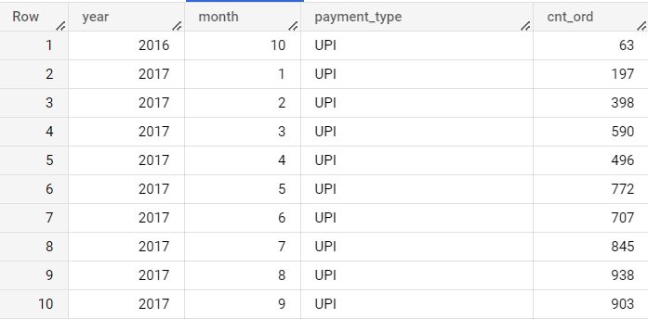

**Part (2) Count of orders based on the no. of payment installments**

**Query Code:**

select

distinct

payment_installments,

count(order_id) over(partition by payment_installments) as cnt_order

from `scaler-dsml-sql-373605.target_sql.payments`

order by payment_installments,cnt_order desc

**Query Result**:

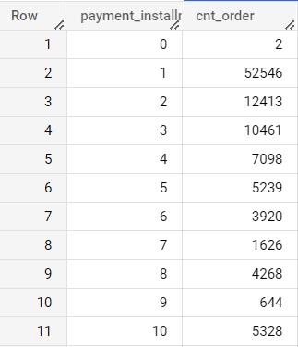

**Q7) Actionable Insights:**

We have been asked to perform data analytics for the given data set, which has information of 100k orders from 2016 to 2018 made at Target in Brazil.

1. In our analysis, we have come across total unique customer States i.e., 27 and 4119 customer cities, The State MG having highest number of cities i.e., 745 and State RR having lowest number of cities i.e., 2.
2. E-commerce growing trend in the number of orders placed by customers has been observed in the first eight months of the year 2017 and 2018 and generally orders peak in August month.
3. More than 75% of the total orders preferred by customers in afternoon to night timestamp zone.
4. It has been observed that the approximate 42% of total orders placed by customers who belong to State SP and State RR having lowest order count i.e.,0.07% of total orders.
5. Top 5 States of Brazil, which have the highest customer potential i.e., SP,RJ,MG,RS and PR which represents 77% of total customers.
6. Highest percentage increase in average cost per order (payment value)  from 2017 to 2018 has been observed in month of July i.e., 19.45% and Highest percentage increase in number of orders from 2017 to 2018 is observed in the March month i.e., 808.63%
7. The State SP having lowest mean freight charges value of 15.15 while State RR has the highest mean freight value of 42.98.
8. The minimum average time of delivery of product is approximately 9 days for states like SP and maximum average time of delivery of product is approximately 29 days for states like RR and AP.
9. It has been observed that month over month and year over year customers' most preferred first payment type is Credit Card and second most preferred payment type is UPI.
10. Based on analysis, more than 50% of customers preferred payment done through one instalment and less than 10% of customers wanted to go with payment having more than 6 instalments.

**Q8) Recommendations:**

As per the findings, the organisation has a major business presence in 55% of total cities in Brazil and even though State MG has the highest number of cities but in terms of customer count it is at third position. So, to gain more customers from other States we can adopt following recommendations:

* As the standard deviation of actual time of delivery of product in Brazil is approximately 10% which is very high and it is directly related to the freight cost and overall cost of product it can easily improve through by adopting proper Network planning like optimal number of locations, size of warehouses/distribution centres, sourcing strategies and best distribution channels.
* Build strong relationship between Value Proposition and operation Strategy like; Everyday low pricing vs Cost efficiency, Customer Experience vs Responsiveness through configure to order, Product innovation vs Efficiency through outsourcing manufacturing & logistics for retainability of customer and expansion of presence in new areas.
* Just to create a unified view of demand, organisations may adopt following steps like; Generate forecast of Consumer demand; Forecast the retailer order; optimise to generate supply plan; aggregate week supply plan to generate financial plan; compare financial plan and adjust trade plan.